Volunteers Needed
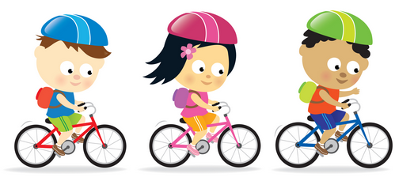
Yes! I am able to volunteer for the Bike Rodeo and support students on Thursday, February 12th.

Name __________________________ Phone # _____________

Child’s Name ________________ Classroom Teacher ________

